Horn Torus
# Source: AI Source: Provided by: [Data Path: Persons Table -> ID Column: 1, Name_En Column: Motasem Essam] -> From: [ChatGPT] on [7/20/2026]
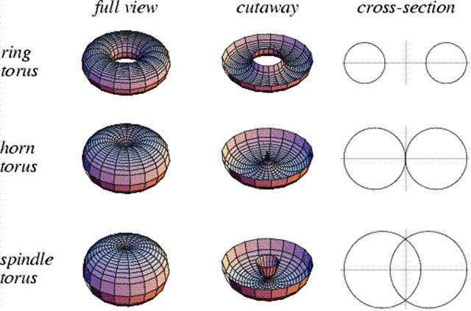
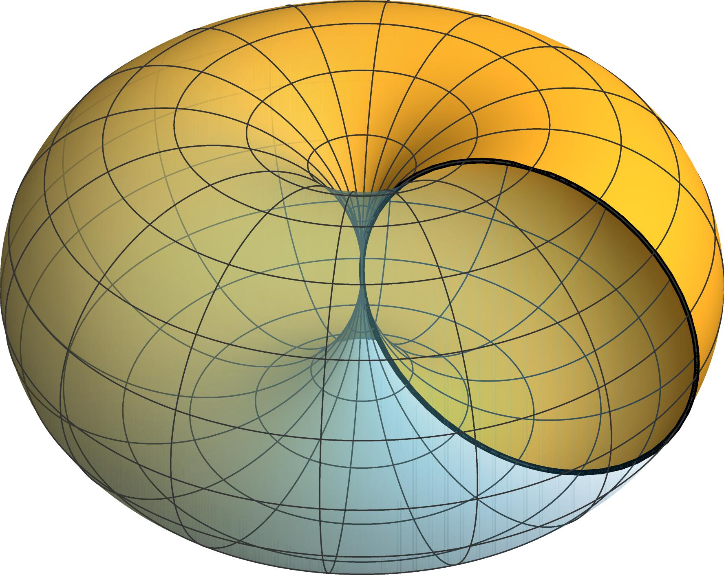
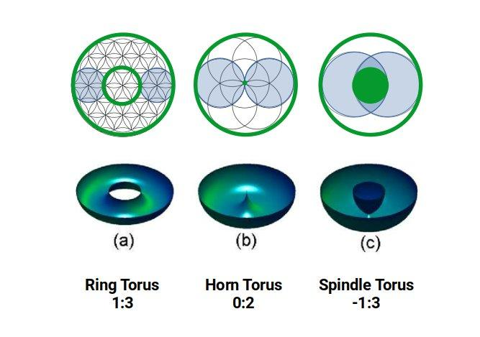
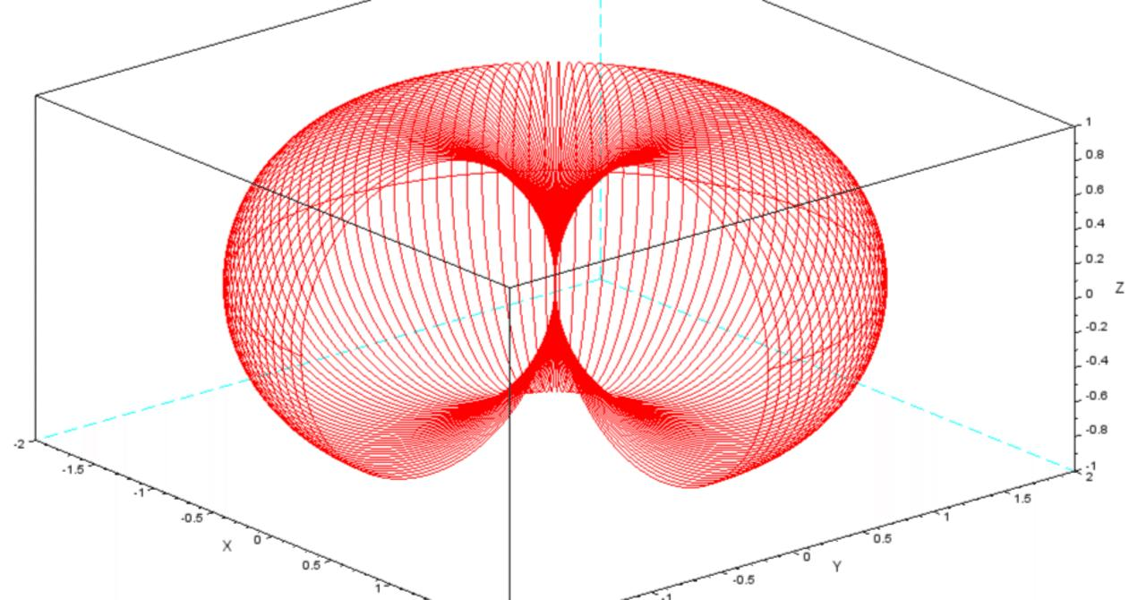

Definition
# Source: AI Source: Provided by: [Data Path: Persons Table -> ID Column: 1, Name_En Column: Motasem Essam] -> From: [ChatGPT] on [7/20/2026]
A Horn Torus is a type of toroidal surface formed by rotating a circle around an axis that lies in the same plane as the circle and is tangent to the circle.
It is characterized by the condition:
$$\boxed{R=r}$$
where:
- $R$= major radius, the distance from the axis of rotation to the center of the generating circle.
- $r$= minor radius, the radius of the generating circle.
Because $R=r$, the generating circle touches the axis of rotation at exactly one point. When the circle is rotated, this produces a toroidal surface whose central hole has collapsed to a single point.
A horn torus is therefore between a ring torus and a spindle torus in the standard classification:
$$\boxed{\begin{aligned}R>r&→\text{Ring Torus} \\ R=r&→\text{Horn Torus} \\ R<r&→\text{Spindle Torus}\end{aligned}}$$

Purpose
# Source: AI Source: Provided by: [Data Path: Persons Table -> ID Column: 1, Name_En Column: Motasem Essam] -> From: [ChatGPT] on [7/20/2026]
The horn torus is useful for:
- Studying special types of toroidal surfaces.
- Understanding surfaces of revolution.
- Studying the transition between ring and spindle tori.
- Calculating surface area and enclosed volume.
- Modeling special geometric surfaces.
- Studying topology and differential geometry.
- Computer graphics and geometric modeling.

Fundamental Elements
# Source: AI Source: Provided by: [Data Path: Persons Table -> ID Column: 1, Name_En Column: Motasem Essam] -> From: [ChatGPT] on [7/20/2026]
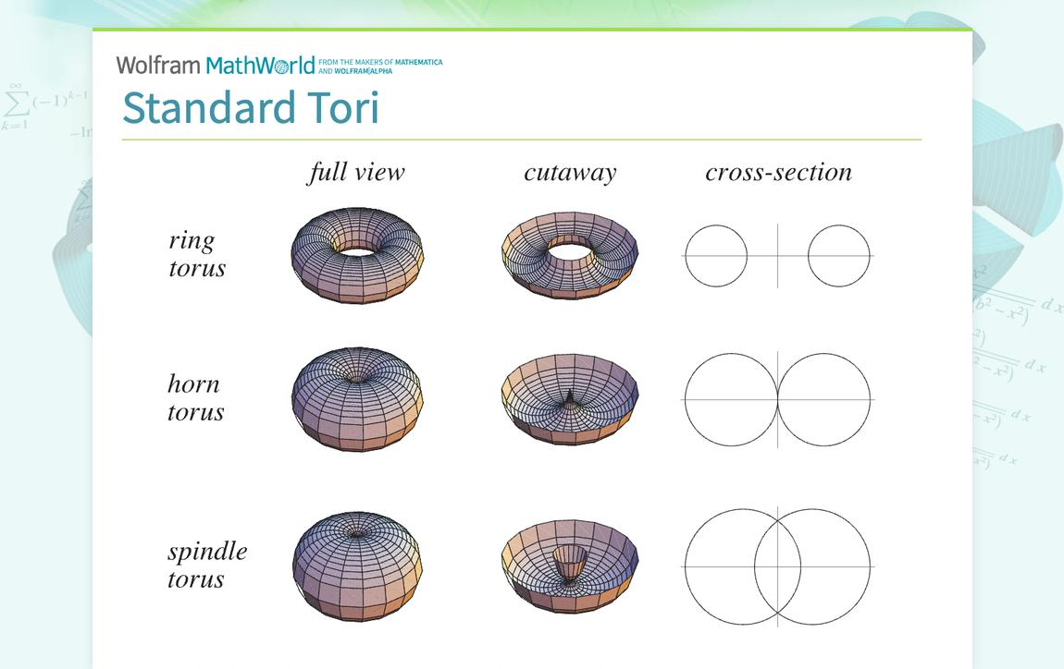

1. Major Radius $R$
# Source: AI Source: Provided by: [Data Path: Persons Table -> ID Column: 1, Name_En Column: Motasem Essam] -> From: [ChatGPT] on [7/20/2026]
The major radius is the distance from the axis of rotation to the center of the generating circle.

2. Minor Radius $r$
# Source: AI Source: Provided by: [Data Path: Persons Table -> ID Column: 1, Name_En Column: Motasem Essam] -> From: [ChatGPT] on [7/20/2026]
The minor radius is the radius of the generating circle.
For a horn torus:
$$\boxed{R=r}$$

3. Axis of Rotation
# Source: AI Source: Provided by: [Data Path: Persons Table -> ID Column: 1, Name_En Column: Motasem Essam] -> From: [ChatGPT] on [7/20/2026]
The axis around which the generating circle is rotated.

4. Generating Circle
# Source: AI Source: Provided by: [Data Path: Persons Table -> ID Column: 1, Name_En Column: Motasem Essam] -> From: [ChatGPT] on [7/20/2026]
The circle that is rotated around the axis to create the toroidal surface.

5. Tangency Point
# Source: AI Source: Provided by: [Data Path: Persons Table -> ID Column: 1, Name_En Column: Motasem Essam] -> From: [ChatGPT] on [7/20/2026]
Because $R=r$, the generating circle touches the axis of rotation at one point.
This point becomes the characteristic single-point contact at the center of the horn torus.

Mathematical Representation
# Source: AI Source: Provided by: [Data Path: Persons Table -> ID Column: 1, Name_En Column: Motasem Essam] -> From: [ChatGPT] on [7/20/2026]
Standard Cartesian Equation
A torus centered around the $z$-axis has the equation:
$${\left(\sqrt{x^{2}+y^{2}}-R\right)}^{2}+z^{2}=r^{2}$$
For a horn torus:
$$R=r$$
Therefore:
$$\boxed{{\left(\sqrt{x^{2}+y^{2}}-r\right)}^{2}+z^{2}=r^{2}}$$
An equivalent polynomial form is:
$$\boxed{{\left(x^{2}+y^{2}+z^{2}\right)}^{2}=4r^{2}\left(x^{2}+y^{2}\right)}$$

Parametric Representation
# Source: AI Source: Provided by: [Data Path: Persons Table -> ID Column: 1, Name_En Column: Motasem Essam] -> From: [ChatGPT] on [7/20/2026]
A horn torus can be represented parametrically by:
$$x=\left(R+r\cos{v}\right)\cos{u} \\ y=\left(R+r\cos{v}\right)\sin{u} \\ z=r\sin{v}$$
with:
$$0≤u<2π$$
and
$$0≤v<2π$$
Since $R=r$:
$$\boxed{x=r\left(1+\cos{v}\right)\cos{u}} \\ \boxed{y=r\left(1+\cos{v}\right)\sin{u}} \\ \boxed{z=r\sin{v}}$$

Surface Area
# Source: AI Source: Provided by: [Data Path: Persons Table -> ID Column: 1, Name_En Column: Motasem Essam] -> From: [ChatGPT] on [7/20/2026]
The surface area formula for a standard torus is:
$$A=4π^{2}Rr$$
For a horn torus:
$$R=r$$
Therefore:
$$\boxed{A=4π^{2}r^{2}}$$
Example
Suppose:
$$r=5\text{ cm}$$
Then:
$$A=4π^{2}{\left(5\right)}^{2} \\ A=100π^{2}$$
Therefore:
$$\boxed{A≈986.96{\text{ cm}}^{2}}$$

Enclosed Volume
# Source: AI Source: Provided by: [Data Path: Persons Table -> ID Column: 1, Name_En Column: Motasem Essam] -> From: [ChatGPT] on [7/20/2026]
The volume associated with the corresponding toroidal solid is:
$$V=2π^{2}Rr^{2}$$
For a horn torus:
$$R=r$$
Therefore:
$$\boxed{V=2π^{2}r^{3}}$$
Example
If:
$$r=5\text{ cm}$$
then:
$$V=2π^{2}{\left(5\right)}^{3} \\ V=250π^{2}$$
Therefore:
$$\boxed{V≈2467.40{\text{ cm}}^{3}}$$

Geometric Structure
# Source: AI Source: Provided by: [Data Path: Persons Table -> ID Column: 1, Name_En Column: Motasem Essam] -> From: [ChatGPT] on [7/20/2026]
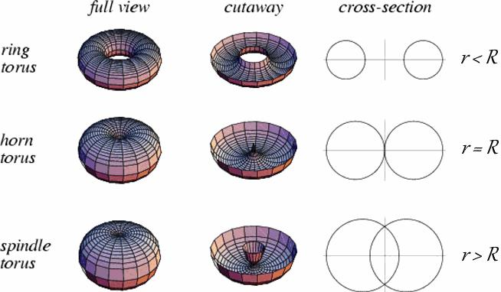
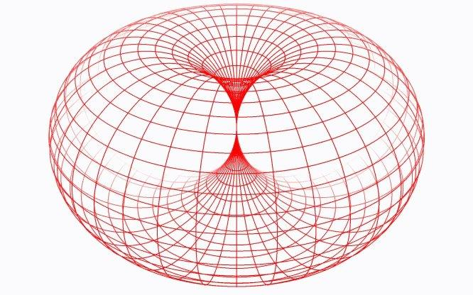
The defining geometric condition is:
$$\boxed{R=r}$$
The generating circle is tangent to the axis of rotation.
This produces three important characteristics:
- The central hole of a ring torus shrinks to zero radius.
- The surface touches itself at one central point.
- The surface separates ring-torus geometry from spindle-torus geometry.

Main Properties
# Source: AI Source: Provided by: [Data Path: Persons Table -> ID Column: 1, Name_En Column: Motasem Essam] -> From: [ChatGPT] on [7/20/2026]
- It is a toroidal surface.
- It is a curved surface.
- It is generated by rotating a circle.
- The generating circle is tangent to the axis of rotation.
- Its defining condition is $R=r$.
- It has no ordinary boundary curve.
- It has rotational symmetry about the axis.
- It has a single special point where the surface meets the axis.
- The central hole of a ring torus has collapsed to a point.
- Its surface area is:
$$\boxed{A=4π^{2}r^{2}}$$
- Its corresponding toroidal volume is:
$$\boxed{V=2π^{2}r^{3}}$$

Horn Torus vs Ring Torus
# Source: AI Source: Provided by: [Data Path: Persons Table -> ID Column: 1, Name_En Column: Motasem Essam] -> From: [ChatGPT] on [7/20/2026]
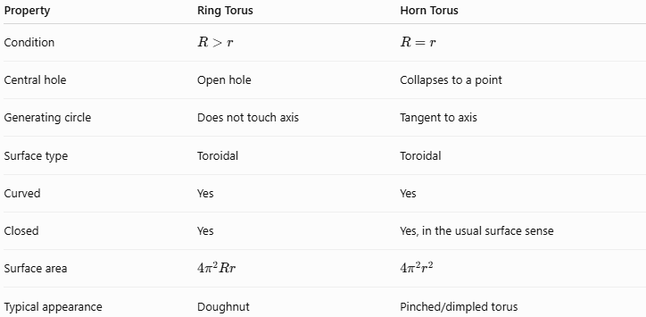
Property | Ring Torus | Horn Torus
Condition | $$R>r$$ | $$R=r$$
Central hole | Open hole | Collapses to a point
Generating circle | Does not touch axis | Tangent to axis
Surface type | Toroidal | Toroidal
Curved | Yes | Yes
Closed | Yes | Yes, in the usual surface sense
Surface area | $$4π^{2}Rr$$ | $$4π^{2}r^{2}$$
Typical appearance | Doughnut | Pinched/dimpled torus

Horn Torus vs Spindle Torus
# Source: AI Source: Provided by: [Data Path: Persons Table -> ID Column: 1, Name_En Column: Motasem Essam] -> From: [ChatGPT] on [7/20/2026]
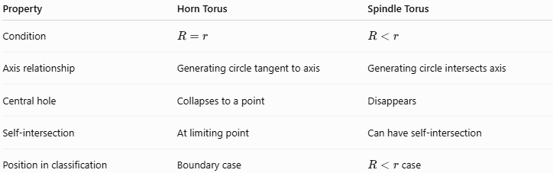
Property | Horn Torus | Spindle Torus
Condition | $$R=r$$ | $$R<r$$
Axis relationship | Generating circle tangent to axis | Generating circle intersects axis
Central hole | Collapses to a point | Disappears
Self-intersection | At limiting point | Can have self-intersection
Position in classification | Boundary case | $R<r$case
The horn torus can therefore be regarded as the transition case between the ring torus and spindle torus.

Example
# Source: AI Source: Provided by: [Data Path: Persons Table -> ID Column: 1, Name_En Column: Motasem Essam] -> From: [ChatGPT] on [7/20/2026]
Consider a horn torus with:
$$R=6\text{ cm}$$
Because it is a horn torus:
$$r=R=6\text{ cm}$$
Surface Area
$$A=4π^{2}Rr \\ A=4π^{2}\left(6\right)\left(6\right) \\ \boxed{A=144π^{2}{\text{ cm}}^{2}}$$
Approximately:
$$\boxed{A≈1421.22{\text{ cm}}^{2}}$$
Volume
$$V=2π^{2}Rr^{2} \\ V=2π^{2}\left(6\right)\left(6^{2}\right) \\ \boxed{V=432π^{2}{\text{ cm}}^{3}}$$
Approximately:
$$\boxed{V≈4263.67{\text{ cm}}^{3}}$$

Real-World and Mathematical Applications
# Source: AI Source: Provided by: [Data Path: Persons Table -> ID Column: 1, Name_En Column: Motasem Essam] -> From: [ChatGPT] on [7/20/2026]
- Geometric modeling.
- Computer graphics.
- CAD and 3D modeling.
- Differential geometry.
- Topological studies of surfaces.
- Mathematical visualization.
- Studying transitions between different toroidal geometries.
- Modeling special surfaces of revolution.

Advantages
# Source: AI Source: Provided by: [Data Path: Persons Table -> ID Column: 1, Name_En Column: Motasem Essam] -> From: [ChatGPT] on [7/20/2026]
- Provides an important limiting case of the torus.
- Has a simple defining condition:
$$R=r$$
- Has relatively simple surface-area and volume formulas.
- Helps explain the transition between ring and spindle tori.
- Useful for studying singular points on surfaces.

Limitations
# Source: AI Source: Provided by: [Data Path: Persons Table -> ID Column: 1, Name_En Column: Motasem Essam] -> From: [ChatGPT] on [7/20/2026]
- It is less common in everyday physical objects than the ring torus.
- Its central point of contact makes its geometry more special than an ordinary doughnut-shaped torus.
- The usual intuitive picture of a torus with a hole is less applicable because the hole has collapsed to a point.
- Its special central point requires care when studying smoothness and curvature.

Key Points
# Source: AI Source: Provided by: [Data Path: Persons Table -> ID Column: 1, Name_En Column: Motasem Essam] -> From: [ChatGPT] on [7/20/2026]
- Horn Torus is a special type of toroidal surface.
- Its defining condition is:
$$\boxed{R=r}$$
- The generating circle is tangent to the axis of rotation.
- The central hole of the ring torus has collapsed to a single point.
- Surface area:
$$\boxed{A=4π^{2}r^{2}}$$
- Corresponding toroidal volume:
$$\boxed{V=2π^{2}r^{3}}$$
- It lies between the ring torus and spindle torus:
$$\boxed{R>r→\text{Ring}} \\ \boxed{R=r→\text{Horn}} \\ \boxed{R<r→\text{Spindle}}$$

Conclusion
# Source: AI Source: Provided by: [Data Path: Persons Table -> ID Column: 1, Name_En Column: Motasem Essam] -> From: [ChatGPT] on [7/20/2026]
A Horn Torus is the special toroidal surface obtained when the major radius equals the minor radius, $R=r$. Its generating circle is tangent to the axis of rotation, causing the central hole characteristic of a ring torus to collapse to a single point. It is therefore the boundary case between a ring torus and a spindle torus and provides an important example of a special surface of revolution in geometry.
Would you like the next entry to cover the spindle torus?

